
Team Assignment 07
HIT
3/17/2012

Software Measurement and Analysis

Team members: | Members ID
Giang Thị Ha Thanh | T097828
Trần Dũng Đạt | T095716
Nguyễn Vũ Trọng Giang | T096656
Huỳnh Chấn Huy | T096498
Tạ Quang Hiệp | T090363
Nguyễn Trần Hồng Phúc | T095014

• Each team creates a budget for the Viking project, including 4-year NPV, ROI, Payback Period and Breakeven Analysis, and recommends to management whether the Viking product is viable, or not.
- Use the VP Marketing Viking Business Estimates spreadsheet (in the Readings folder) as input to your budget.

- Viking Roadmap

Assumption Roadmap for 4th year of Viking Project and its budget
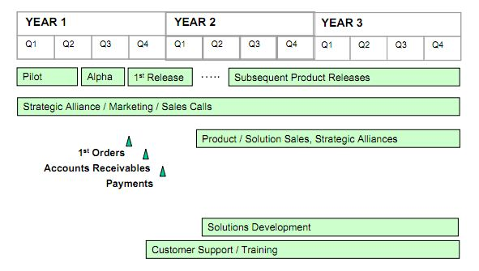
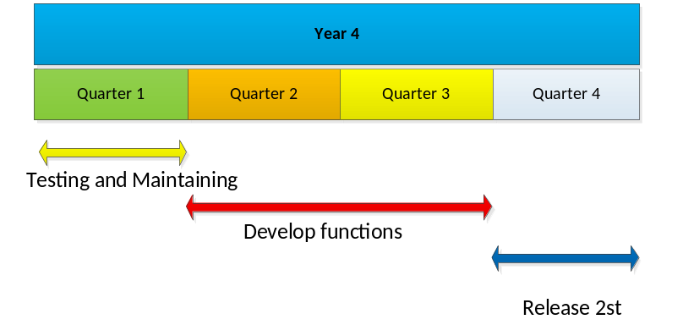

Based on Work Breakdown Structure which developed in the previous team assignment, we propose ​​the charges should be spent on development projects in 4 years.
The first year of the Viking project, investment costs mainly use for system development, costs for changes & risk management, contingency management. The following table estimates the total cost of 1st year:

On the project budget table, salary paid for developer take large amount. Salary Table below will list the number of developer team participating in the project and for their salary corresponding to their work hours. However, not every member also participate throughout the project, table Salary will based on participate of each member in WBS.

In 2nd and 3rd it’s the release time, budget cost mostly used for training customer to use the tool and for maintenance product

According to customer demand, in year 4 project team will develop a number of functions. Development stage lasts from start ò Q2 to the end of Q3. On Q4 the product will be release, install, supported.

- Tools to estimate
- Đưa phương pháp tính toán và giải thích vì sao chọn
- Kết luận

